|  |
| --- |
| *Dear Candidate,*  *It’s our pleasure to invite you to perform a test set given below. Please use any IDE at your choice. The source code result (including photos, assets, etc.) should be zipped and return to our Technical Recruiter via email.*  *Though we do not limit the timing, we estimate that it may take you 4 hours to complete the task.*  *Thank you and we look forward to review the result!* |

# HtmlDesign Task

**Modify index.html so that it reflects the given design.**

Task description

A small digital agency asked you to create a landing page for them (image in the next page). They have sent over a design, all graphical assets and content of the page. Your task is to modify index.html (you can add extra files if needed) so that it reflects the given design. The details are specified below:

* Use the provided font for texts
* Check the preview image for other information like font-size, color …

Your solution should:

* Be written in HTML5
* Be compressed in a .zip file containing the index.html file

Your solution does not have to be pixel-perfect.

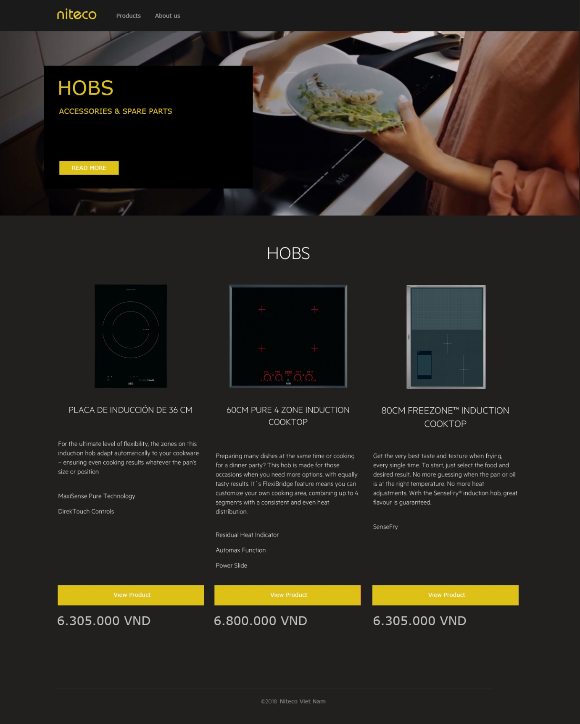

# Logic Task

The client has a search page with a search box for inputing search content and a body for displaying the result. The client wants the search function on the page to work like the description below:

* It should work like the smart search, that means the result will be shown while users are typing. The result should not be shown immediately, it should be shown after 3 seconds when users stop typing.

Your task is creating the search page, and you are not allowed to use any libraries or frameworks, only using native javascript. **Your final result** should include some files: **index.html, main.js, data.json** while index.html is used for displaying the search box and results, main.js is used for the logic search function, and data.json is used for mock data of the search result from an api. The style and mock data for the page are not important, so that it is up to you to choose.

*------------------------------------End of the assignment------------------------------------*